Budget Planning of

Institute of Information Technology,

University of Dhaka

**LETTER OF TRANSMITTAL**

Dr. Md. Mahbubul Alam Joarder

Professor

Institute of Information Technology (IIT)

University of Dhaka

November 17, 2016

Dear Sir,

We have prepared the enclosed report on Software Requirements Specifications of “Budget Planning” for your approval. This report details the requirements we have gathered for the project.

The primary purpose of this report is to find out and analyzing requirements for the project. This report includes the details of each steps that we followed to collect the requirements.

Sincerely Yours,

Md. Arafat Hussain (BSSE-0601)

Pritom Saha Akash (BSSE-0604)

Sharafat Ahmed (BSSE-0617)

Md. Habibur Rahman (BSSE-0623)

Md. Julfikar Rahman (BSSE-0640)

**Executive Summary**

A Budget Planning system, proposed by Institute of Information Technology, University of Dhaka (IIT, DU) for the students of Institute of Information Technology, University of Dhaka. The purpose of this system is to help the Budget Committee of IIT to take decision about budget more efficiently and digitally. It would be a web-based system where an official will propose a budget and then Budget committee will approve or disapprove the budget. This report provides the Software Requirements Specifications (SRS) to develop the system.

Contents

[Chapter 1: Introduction 6](file:///C:\\Users\\bsse0\\Desktop\\MIS-SRS-Group-Final.docx" \l "_Toc467145801)

[1.1 Purpose 6](file:///C:\\Users\\bsse0\\Desktop\\MIS-SRS-Group-Final.docx" \l "_Toc467145802)

[1.2 Intended Audience 6](file:///C:\\Users\\bsse0\\Desktop\\MIS-SRS-Group-Final.docx" \l "_Toc467145803)

[1.3 Overview 6](file:///C:\\Users\\bsse0\\Desktop\\MIS-SRS-Group-Final.docx" \l "_Toc467145804)

[Chapter 2: Inception 7](file:///C:\\Users\\bsse0\\Desktop\\MIS-SRS-Group-Final.docx" \l "_Toc467145805)

[2.1 Introduction 7](file:///C:\\Users\\bsse0\\Desktop\\MIS-SRS-Group-Final.docx" \l "_Toc467145806)

[2.1.1 Identifying Stakeholders 7](file:///C:\\Users\\bsse0\\Desktop\\MIS-SRS-Group-Final.docx" \l "_Toc467145807)

[2.1.2 Asking the First Questions 7](file:///C:\\Users\\bsse0\\Desktop\\MIS-SRS-Group-Final.docx" \l "_Toc467145808)

[2.1.3 Recognizing Multiple Viewpoints 8](file:///C:\\Users\\bsse0\\Desktop\\MIS-SRS-Group-Final.docx" \l "_Toc467145809)

[2.1.4 Working towards Collaboration 8](file:///C:\\Users\\bsse0\\Desktop\\MIS-SRS-Group-Final.docx" \l "_Toc467145810)

[2.2 Conclusion 9](file:///C:\\Users\\bsse0\\Desktop\\MIS-SRS-Group-Final.docx" \l "_Toc467145811)

[Chapter 3: Elicitation 10](file:///C:\\Users\\bsse0\\Desktop\\MIS-SRS-Group-Final.docx" \l "_Toc467145812)

[3.1 Introduction 10](file:///C:\\Users\\bsse0\\Desktop\\MIS-SRS-Group-Final.docx" \l "_Toc467145813)

[3.2 Eliciting Requirements 10](file:///C:\\Users\\bsse0\\Desktop\\MIS-SRS-Group-Final.docx" \l "_Toc467145814)

[3.3 Collaborative Requirements Gathering 10](file:///C:\\Users\\bsse0\\Desktop\\MIS-SRS-Group-Final.docx" \l "_Toc467145815)

[3.4 Quality Function Deployment 10](file:///C:\\Users\\bsse0\\Desktop\\MIS-SRS-Group-Final.docx" \l "_Toc467145816)

[3.4.1 Normal Requirements 10](file:///C:\\Users\\bsse0\\Desktop\\MIS-SRS-Group-Final.docx" \l "_Toc467145817)

[3.4.2 Expected Requirements 11](file:///C:\\Users\\bsse0\\Desktop\\MIS-SRS-Group-Final.docx" \l "_Toc467145818)

[3.4.3 Exciting Requirements 11](file:///C:\\Users\\bsse0\\Desktop\\MIS-SRS-Group-Final.docx" \l "_Toc467145819)

[3.5 Usage Scenario 11](file:///C:\\Users\\bsse0\\Desktop\\MIS-SRS-Group-Final.docx" \l "_Toc467145820)

[Chapter 4: Scenario Based Model 12](file:///C:\\Users\\bsse0\\Desktop\\MIS-SRS-Group-Final.docx" \l "_Toc467145821)

[4.1 Introduction 12](file:///C:\\Users\\bsse0\\Desktop\\MIS-SRS-Group-Final.docx" \l "_Toc467145822)

[4.2 Use Case Scenario 12](file:///C:\\Users\\bsse0\\Desktop\\MIS-SRS-Group-Final.docx" \l "_Toc467145823)

[4.3 Use Case Description 12](file:///C:\\Users\\bsse0\\Desktop\\MIS-SRS-Group-Final.docx" \l "_Toc467145824)

[4.3.1 Use Case: Budget Planning System 13](file:///C:\\Users\\bsse0\\Desktop\\MIS-SRS-Group-Final.docx" \l "_Toc467145825)

[4.3.2 Use Case: Add User 14](file:///C:\\Users\\bsse0\\Desktop\\MIS-SRS-Group-Final.docx" \l "_Toc467145826)

[4.3.3 Use Case: Initiate Budget 15](file:///C:\\Users\\bsse0\\Desktop\\MIS-SRS-Group-Final.docx" \l "_Toc467145827)

[4.3.4 Use Case: Prepare Budget 16](file:///C:\\Users\\bsse0\\Desktop\\MIS-SRS-Group-Final.docx" \l "_Toc467145828)

[4.3.5 Use Case: Budget Approval 17](file:///C:\\Users\\bsse0\\Desktop\\MIS-SRS-Group-Final.docx" \l "_Toc467145829)

[Chapter 5: Data Model 20](file:///C:\\Users\\bsse0\\Desktop\\MIS-SRS-Group-Final.docx" \l "_Toc467145830)

[5.1 Data Modeling Concepts: 20](file:///C:\\Users\\bsse0\\Desktop\\MIS-SRS-Group-Final.docx" \l "_Toc467145831)

[5.2 Identifying Data Objects: 20](file:///C:\\Users\\bsse0\\Desktop\\MIS-SRS-Group-Final.docx" \l "_Toc467145832)

[5.3 Data Tables 22](file:///C:\\Users\\bsse0\\Desktop\\MIS-SRS-Group-Final.docx" \l "_Toc467145833)

[Chapter 6: Class Based Model 23](file:///C:\\Users\\bsse0\\Desktop\\MIS-SRS-Group-Final.docx" \l "_Toc467145834)

[6.1 Introduction 23](file:///C:\\Users\\bsse0\\Desktop\\MIS-SRS-Group-Final.docx" \l "_Toc467145835)

[6.2 General Classification 23](file:///C:\\Users\\bsse0\\Desktop\\MIS-SRS-Group-Final.docx" \l "_Toc467145836)

[6.3 Selection Criteria 24](file:///C:\\Users\\bsse0\\Desktop\\MIS-SRS-Group-Final.docx" \l "_Toc467145837)

[6.4 Attribute Selection 25](file:///C:\\Users\\bsse0\\Desktop\\MIS-SRS-Group-Final.docx" \l "_Toc467145838)

[6.5 Defining Methods 25](file:///C:\\Users\\bsse0\\Desktop\\MIS-SRS-Group-Final.docx" \l "_Toc467145839)

[6.6 Class Card 26](file:///C:\\Users\\bsse0\\Desktop\\MIS-SRS-Group-Final.docx" \l "_Toc467145840)

[Chapter 7: Flow Oriented Model 27](file:///C:\\Users\\bsse0\\Desktop\\MIS-SRS-Group-Final.docx" \l "_Toc467145841)

[7.1 Introduction 27](file:///C:\\Users\\bsse0\\Desktop\\MIS-SRS-Group-Final.docx" \l "_Toc467145842)

[7.2 Data Flow Diagram (DFD) 27](file:///C:\\Users\\bsse0\\Desktop\\MIS-SRS-Group-Final.docx" \l "_Toc467145843)

[Chapter 8: Behavioral Model 30](file:///C:\\Users\\bsse0\\Desktop\\MIS-SRS-Group-Final.docx" \l "_Toc467145844)

[8.1 Introduction 30](file:///C:\\Users\\bsse0\\Desktop\\MIS-SRS-Group-Final.docx" \l "_Toc467145845)

[8.2 Identifying Events 30](file:///C:\\Users\\bsse0\\Desktop\\MIS-SRS-Group-Final.docx" \l "_Toc467145846)

[8.3 State Transition Diagram 31](file:///C:\\Users\\bsse0\\Desktop\\MIS-SRS-Group-Final.docx" \l "_Toc467145847)

[Chapter 9: Sequence Diagram 33](file:///C:\\Users\\bsse0\\Desktop\\MIS-SRS-Group-Final.docx" \l "_Toc467145848)

[Chapter 10: Conclusion 35](file:///C:\\Users\\bsse0\\Desktop\\MIS-SRS-Group-Final.docx" \l "_Toc467145849)

# Chapter 1: Introduction

## 1.1 Purpose

The purpose of this document is to present a detailed description of the website “Budget Planning of IIT, DU”. It will explain the purpose and features of the website, the interfaces of the website, what the procedure website will follow. This document is intended for both the stakeholders and the developers of the website.

## 1.2 Intended Audience

This SRS is intended for several audiences, including the customer, as well as the project managers, designers, developers and testers.

* The customer will use this SRS to verify that the developer team has created a product that is acceptable to the customer.
* As we are doing this project as a Management Information Systems project, we will use this SRS to plan milestones and a delivery date of the system.
* We will use this SRS as a basis for creating the system’s design. We will continually refer back to this SRS to ensure that the system is designing will fulfill the customer’s needs.
* We will use this SRS as a basis for developing the system’s functionality. We will link the requirements defined in this SRS to ensure that we have created software that will fulfill all of the customer’s documented requirements.

## 1.3 Overview

The second chapter Inception, of this document describes how the functional requirements are gained by talking with stakeholders, meeting etc. The third chapter, Elicitation elicits the requirements gained via Inception. The next chapters, Scenario Based Modeling, Data Based Modeling, Class Based Modeling, Data Flow Diagram, and Behavioral Model are written primarily for the developers and describes in technical terms the details of the functionality of the product.

# Chapter 2: Inception

## 2.1 Introduction

Inception is the beginning phase of requirements engineering. It defines how does a software project get started and what is the scope and nature of the problem to be solved. The goal of the inception phase is to identify concurrence needs and conflict requirements among the stakeholders of a software project. To establish the groundwork we have worked with the following factors related to inception phase:

* Identifying Stakeholders
* Asking the First Questions
* Recognizing Multiple Viewpoints
* Working towards Collaboration

### 2.1.1 Identifying Stakeholders

Stakeholder refers to any person or group who will be affected by the system directly or indirectly. Stakeholders include end-users who interact with the system and everyone else in an organization that may be affected by its installation. To identify the stakeholders we consulted with Director of IIT and asked him following questions:

* Who will be using the project outcomes?
* Who gets to make the decisions about the project (if this is different from the money source)?
* Who has resources I need to get the project done?
* Whose work will my project affect? (During the project and also once the project is completed)

Concluding thoughts on Stakeholders, we have identified following stakeholders for our automated Budget Planning:

* Admin: The director will be the admin of this system. He will start a budget for a year.
* Budget Committee: The system is for helping Budget Committee of IIT to plan a budget for IIT efficiently.
* Budget Officer: The budget officer will get suggestion about the sectors of previous years on which money has been spent as per budgets of previous years. He/she will also get a form to submit all the possible sources of money for the running year.

### 2.1.2 Asking the First Questions

We set my first set of context-free questions focuses on the customer and other stakeholders, overall project goals and benefits. The questions are mentioned above. These questions helped us to identify all stakeholders, measurable benefit of the successful implementation and possible alternatives to custom software development. Next set of question helped us to gain a better understanding of problem and allows the customer to voice his or her perception about the solution. The final set of question focused on the effectiveness of the communication activity itself.

### 2.1.3 Recognizing Multiple Viewpoints

We have collected these viewpoints by discussing with the teachers and students of IIT.

1. **Admin:**
2. Secured system.
3. Easy User Interface
4. Easy to maintain
5. **Budget Committee:**
6. Web based system
7. Compatible with current system

3. **Budget Officer:**

1. Good suggestion
2. Easy UX

### 2.1.4 Working towards Collaboration

Every stakeholder has their own requirements. We have followed following steps to merge these requirements:

* Identify the common
* Categorize the requirements
* Take priority points for each requirement from stakeholders and on the basis of this voting prioritize the requirements
* Make final decision about the requirements

**Common Requirements**:

* Web-Based Interfaces.
* The application can be accessed from any computer that has Internet access.
* Easy Access.
* Maintain a database to store all information.

**Final Requirements:**

We have finalized following requirements for the system by categorizing and prioritizing the requirements:

* Error free system (Maximum 5% error may be considerable).
* Web-based interfaces.
* Accessible via the Internet.
* Allow valid users to login and logout.
* Restrict access to functionality of the system based upon user roles.
* Allow admin to start a budget
* Allow Budget officer to submit a budget proposal
* Allow Budget officer to submit possible sources of money
* Allow Budget Committee members to vote on proposed budget and comment on it

## 2.2 Conclusion

Inception phase helped me to establish basic understanding about budget planning system of IIT and identify the people who will be benefited if Budget Planning System becomes automated, define the nature of the Budget Planning System software and establish a preliminary communication with our stakeholders.

# Chapter 3: Elicitation

## 3.1 Introduction

Elicitation is a task that helps the customer to define what is required. To complete the elicitation step we have faced many problems like problems of scope, problems of volatility and problems of understanding. However, this is not an easy task. To help overcome these problems, We have worked with the Eliciting requirements activity in an organized and systematic manner.

## 3.2 Eliciting Requirements

Unlike inception where Q&A (Question and Answer) approach is used, elicitation makes use of a requirements elicitation format that combines the elements of problem solving, elaboration, negotiation, and specification. It requires the cooperation of a group of end-users and developers to elicit requirements .To elicit requirements we have completed following four works:

* **Collaborative Requirements Gathering**
* **Quality Function Deployment**
* **Usage Scenarios**
* **Elicitation work products**

## 3.3 Collaborative Requirements Gathering

Many different approaches to collaborative requirements gathering have been proposed. Each makes use of a slightly different scenario. We have completed following steps to do it:

1. The meetings were conducted with admin. He was questioned about the requirements and expectations from the automated Budget Planning system.
2. Budget committee members were asked about the problems he is facing with the current manual system. At last we have selected our final requirement list from the meetings.

## 3.4 Quality Function Deployment

Quality Function Deployment (QFD) is a technique that translates the needs of the customer into technical requirements for software .It concentrates on maximizing customer satisfaction from the Software engineering process .With respect to my project the following requirements are identified by a QFD.

### 3.4.1 Normal Requirements

Normal requirements consist of objectives and goals that are stated during the meeting with the customers. Normal requirements of my project are:

* Accessible via the Internet.
* Allow admin to start budget.
* Allow Budget officer to submit a budget proposal
* Allow Budget officer to submit possible sources of money
* Allow Budget Committee members to vote on proposed budget and comment on it

### 3.4.2 Expected Requirements

* Restrict access to functionality of the system based upon user roles.
* Allow valid user to log in and log out to the system.

### 3.4.3 Exciting Requirements

These requirements are for features that go beyond the customer's expectations and prove to be very satisfying when present:

* Good suggestion algorithm will be implemented for suggesting budget to the Budget Officer
* The user interface should provide appropriate error messages.

## 3.5 Usage Scenario

There is a Budget Planning in Institute of Information Technology, University of Dhaka. It helps to prepare and approve budget annually.

There is an admin who register the members of budget committee and a budget officer. The registration form contains the email address and the user type. When admin register a user an email is automatically sent to that user with a temporary password.

At the beginning of every fiscal year admin initiate the process by assigning the start and end date. At this time an email is sent to all user containing the message that a budget is going to start as well as the time period.

After receiving the email the budget officer start to prepare the budget by logging the system. At first he/she need to input all source of money and amount of this fiscal year. Then he/she he get a form containing the sectors and proposed amount of money. He/she can add and remove a sector. After preparing the proposed budget he/she submit it for approval and an email is sent to all members of budget committee containing the message that a budget is proposed.

After receiving the email they log in to the system and check the proposed budget. Then he/she express his/her opinion by voting. If his/her opinion is negative he/she can make a comment by expressing his/her dissatisfaction.

# Chapter 4: Scenario Based Model

## 4.1 Introduction

In this model the system is described from the user’s point of view. As this is the first model, it serves as input for creation of other modeling elements.

## 4.2 Use Case Scenario

As requirements are gathered, an overall vision of system functions and features begins to materialize. To understand how these functions and features will be used by different classes of end users, developers and users create a set of scenarios, called use case scenario, that identify a thread of usage for the system to be constructed.

## 4.3 Use Case Description

We will elaborate use case scenario to use case diagram, description, activity diagram & swim-lane diagram. Here is the use case diagram of level-0 for Budget Planning in Figure-1:



Figure 1: Use Case Level 0

### 

### 4.3.1 Use Case: Budget Planning System

This elaborated form of use case (level-0) shown in Figure-2

****

Figure 2: Use Case Diagram Level 1.1

### 4.3.2 Use Case: Add User

The use case of add user is elaborated in Figure: 3



Figure 3: Use Case Diagram Level 1.2

### 4.3.3 Use Case: Initiate Budget

The use case of initiate budget is elaborated in Figure: 4



Figure 4: Use Case Diagram Level 1.3

### 4.3.4 Use Case: Prepare Budget

The use case of prepare budget is elaborated in Figure: 5



Figure 5: Use Case Diagram Level 1.4

### 4.3.5 Use Case: Budget Approval

The use case of budget approval is elaborated in Figure: 6



Figure 6: Use Case Diagram Level 1.5

**Primary Actors:**

1. Admin

2. Budget Committee Members

3. Budget Officer

**Secondary actor:**

None.

Activity diagram of Budget Planning System is given below in figure in Figure-7

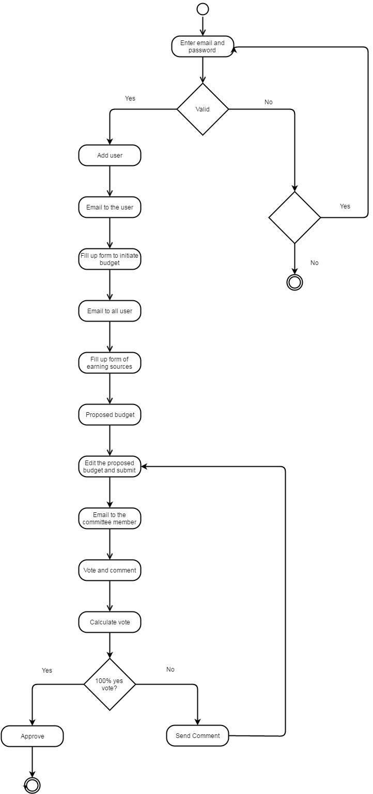

Figure 7: Activity Diagram of Budget Planning System

Swim lane Diagram of Budget Planning System is shown in figure 8

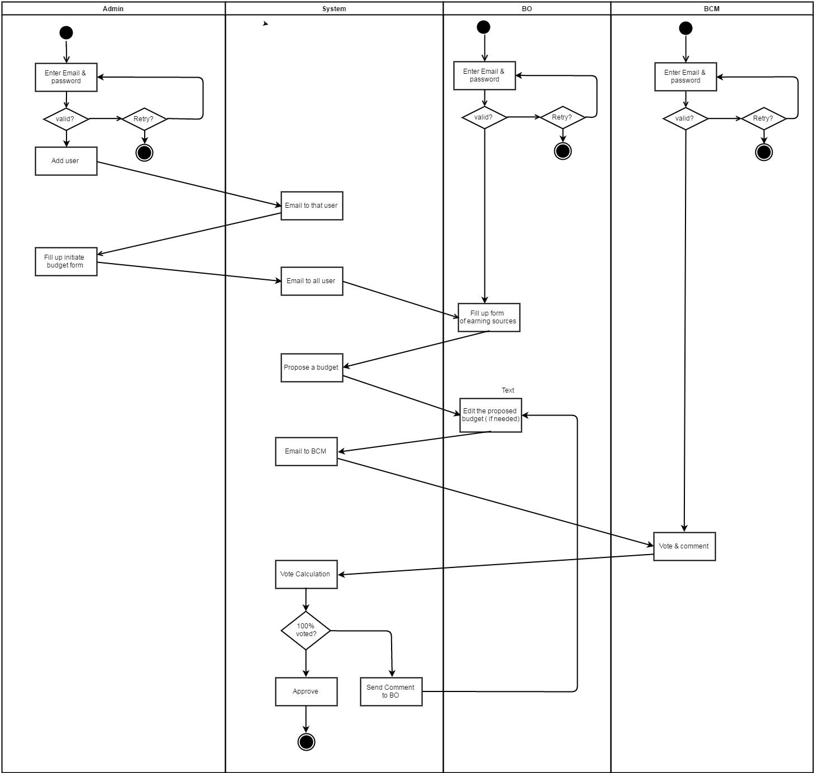

Figure 8: Swim Lane Diagram of Budget Planning System

# Chapter 5: Data Model

## 5.1 Data Modeling Concepts:

If software requirements include the need to create, extend, or interface with a database or if complex data structures must be constructed and manipulated, the software team may choose to create a data model as part of overall requirements modeling.

## **5.2 Identifying Data Objects:**

A data object is a representation of information which has different properties or attributes that must be understood by software. We found following data objects in our Budget Planning System.

**Table 1:** Identifying data object

|  |  |  |  |
| --- | --- | --- | --- |
| **No.** | **Noun** | **Remarks** | **Attributes** |
| 1 | Admin | Problem space | - |
| 2 | User | Solution Space | 5,6,7,8 |
| 3 | BCM | Problem space | - |
| 4 | BO | Problem space | - |
| 5 | E-mail | Solution Space | - |
| 6 | User name | Solution Space | - |
| 7 | Password | Solution Space | - |
| 8 | User type | Solution Space | - |
| 9 | Fiscal Year | Solution Space | - |
| 10 | Start date | Solution Space | - |
| 11 | End-date | Solution Space | - |
| 12 | Voting-time | Solution Space | - |
| 13 | Proposed budget | Solution Space |  |
| 14 | Message | Problem Space | - |
| 15 | Earning-source | Solution Space | - |
| 16 | Money | Solution Space | - |
| 17 | Sector | Solution Space | - |
| 18 | Vote | Solution Space | - |
| 19 | Comment | Solution Space | - |
| 20 | Dissatisfaction | Problem space | - |
| 21 | Percentage | Solution Space | - |

|  |  |  |  |
| --- | --- | --- | --- |
| 22 | Budget Initiation | Solution space | 10,11,12,21 |
| 23 | Earning source | Solution space | 15,16 |
| 24 | Budget | Solution space | 9,16,17,18,19 |

## 5.3 Data Tables

|  |  |  |  |  |
| --- | --- | --- | --- | --- |
| User | | | | |
| Field name | Type | Null | Key | Description |
| UserEmail | Varchar2 | No | Pk | User Email |
| UserName | Varchar2 | No | - | User name |
| UserType | Varchar2 | No | - | User type |
| Password | Varchar2 | No | - | Password of user |
| Vote | Varchar2 | Yes | - | Yes/No |
| Comment | Varchar2 | Yes | - | A comment on Budget |

|  |  |  |  |  |
| --- | --- | --- | --- | --- |
| Budget Initiation | | | | |
| Field name | Type | Null | Key | Description |
| StartDate | Varchar2 | No | Pk | Start Date of Budget |
| EndDate | Varchar2 | No | - | End Date of Budget |
| VotingTime | Varchar2 | No | - | Time when user voted |
| Percentage | double | No | - | A threshold value |

|  |  |  |  |  |
| --- | --- | --- | --- | --- |
| Budget | | | | |
| Field name | Type | Null | Key | Description |
| Year | Int | No | Pk | Year of a budget |
| SectorName | Varchar2 | No | - | Name of sectors of budget |
| Amount | Int | No | - | Amount of each sector |
| SectorID | Int | No | Pk | An ID for each sector |

|  |  |  |  |  |
| --- | --- | --- | --- | --- |
| Earning Source | | | | |
| Field name | Type | Null | Key | Description |
| Source | Varchar2 | No | - | Source of possible income |
| Amount | Int | No | - | Amount of each resource |
| Year | Int | No | - | Year of a budget |
| RecouceID | int | No | Pk | An ID for each resource |

# Chapter 6: Class Based Model

## 6.1 Introduction

Class-based modeling represents the objects that the system will manipulate, the operations that will be applied to the objects, relationships between the objects and the collaborations that occur between the classes that are defined.

## 6.2 General Classification

To identify potential classes, we have first find out all the nouns which are in solution space. Then analyses the nouns to find out if they are in following zero or more criteria:

1. External Entity

2. Thing

3. Occurrence

4. Role

5. Organizational Unit

6. Place

7. Structure

**Table 2**: Potential Class Identification

|  |  |  |  |
| --- | --- | --- | --- |
| **No.** | **Noun** | **Remarks** | **General classification** |
| 1 | Admin | Problem space | - |
| 2 | Registration | Problem space | - |
| 3 | BCM | Problem space | - |
| 4 | BO | Problem space | - |
| 5 | E-mail | Solution Space | 2 |
| 6 | User name | Solution Space | 2 |
| 7 | Password | Solution Space | 2 |
| 8 | User type | Solution Space | 2 |
| 9 | Fiscal Year | Solution Space | 2 |
| 10 | Start date | Solution Space | 2 |
| 11 | End-date | Solution Space | 2 |
| 12 | Voting-time | Solution Space | 2 |
| 13 | Proposed budget | Solution Space | 2 |
| 14 | Message | Problem Space | - |
| 15 | Earning-source | Solution Space | 2 |
| 16 | Money | Solution Space | 2 |
| 17 | Sector | Solution Space | 2 |
| 18 | Vote | Solution Space | 2 |
| 19 | Comment | Solution Space | 2 |
| 20 | Dissatisfaction | Problem space | - |
| 21 | Percentage | Solution Space | 2 |
| 22 | Budget approval | Solution Space | 3 |
| 23 | User | Solution Space | 4 |
| 24 | Budget Preparation | Solution Space | 3 |

## 

## 6.3 Selection Criteria

Coad and Yourdon suggest six selection characteristics that should be used to consider each potential class for inclusion in the analysis model:

1. Retained Information

2. Needed Services

3. Multiple Attributes

4. Common Attributes

5. Common operations

6. Essential Requirements

***Table 3****: Class Identification*

|  |  |  |
| --- | --- | --- |
| **No.** | **Noun** | **Characteristics** |
| 5 | E-mail | 1 |
| 6 | User name | 1 |
| 7 | Password | 1 |
| 8 | User type | 1 |
| 9 | Fiscal Year | 1 |
| 10 | Start date | 1 |
| 11 | End-date | 1 |
| 12 | Voting-time | 1 |
| 13 | Proposed budget | 1 |
| 15 | Earning-source | 1 |
| 16 | Money | 1 |
| 17 | Sector | 1 |
| 18 | Vote | 1 |
| 19 | Comment | 1 |
| 21 | Percentage | 1 |
| 22 | Budget approval | 3,5 |
| 23 | User | 1,2,3,4,5 |
| 24 | Budget Preparation | 1,3,5 |

## 6.4 Attribute Selection

Here we have found attributes for selected classes:

**Table 4**: Attribute Selection

|  |  |  |
| --- | --- | --- |
| **No.** | **Class** | **attributes** |
| 1. | User | UserName, E\_mail, UserType, Password |
| 2. | BudgetPreparation | StartDate, EndDate, FiscalYear, EarningSector, ExpenseSector, amount |
| 3. | BudgetApproval | Comment, Vote |

## 6.5 Defining Methods

Here are all the selected methods found from the usage scenario shown in Table 5.

**Table 5**: Defining Method

|  |  |  |
| --- | --- | --- |
| **No.** | **Class Name** | **Methods** |
| 1. | User | registerUser(), removeUser(), logIn(), logout(), sendEmail(), changePassword() |
| 2. | BudgetPreparation | initiateBudget(), makeEarningList(), suggestForBudget(), makeProposedBudget() |
| 3. | BudgetApproval | budgetApproval(), makeComment(), giveVote() |

## 6.6 Class Card

Class card represents a graphical view of properties, methods, responsibility and collaborator for each class

|  |  |
| --- | --- |
| BudgetPreparation | |
| Attributes | Methods |
| StartDate EndDate FiscalYear EarningSector ExpenseSector amount | initiateBudget()  makeEarningList() suggestForBudget() makeProposedBudget() |
| Responsibility | Collaborating class |
|  |  |

|  |  |
| --- | --- |
| User | |
| Attributes | Methods |
| UserName E\_mail  UserType Password | registerUser() removeUser() logIn()  logout() sendEmail() changePassword() |
| Responsibility | Collaborating class |
|  |  |

|  |  |
| --- | --- |
| BudgetApproval | |
| Attributes | Methods |
| Comment,Vote | budgetApproval() makeComment() giveVote() |
| Responsibility | Collaborating class |
|  |  |

# Chapter 7: Flow Oriented Model

## 7.1 Introduction

Although data flow-oriented modeling is perceived as an outdated technique by some software engineers, it continues to be one of the most widely used requirements analysis notations in use today.

## 7.2 Data Flow Diagram (DFD)

The Data Flow Diagram (DFD) takes an input-process-output view of a system. Data objects flow into the software, are transformed by processing elements and resultant data objects flow out of the software. Data objects are represented by labeled arrows and transformations are represented by circles.

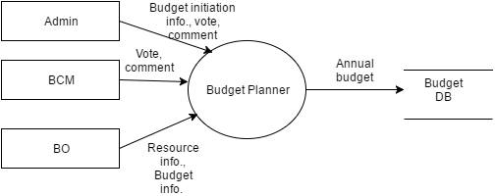

Figure 9: DFD Level 0



Figure 10: DFD Level-1.1

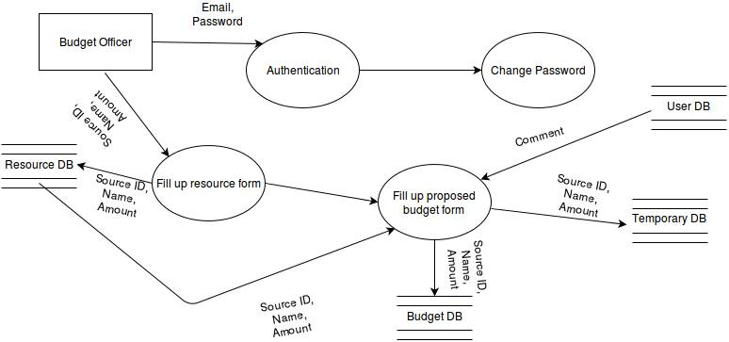

Figure 11: DFD Level 1.2

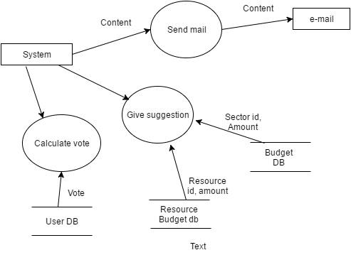

Figure 12: DFD Level 1.3

# Chapter 8: Behavioral Model

## 8.1 Introduction

Behavior modeling is also referred to as State modeling, State machines and State transition matrix. Behavior modeling is when one thinks of his ideas in terms of states and transitions. This requires both identifying all of the interesting states of being that software or its components are likely to be in. And also, at a high level, abstracting what events are likely to cause software or its components to change between states of being.

## 8.2 Identifying Events

Here I have identified events from the **Usage Scenario** and listed their corresponding initiators & collaborators.

**Table 6**: Event Identification

|  |  |  |  |
| --- | --- | --- | --- |
| No. | Events | Initiating Class | Collaborating Class |
| 1 | Log In | User | - |
| 2 | Register user | User | - |
| 3 | Remove user | User | - |
| 4 | Initiate budget | Budget preparation | - |
| 5 | Send email | User | - |
| 6 | Fill up earning source form | Budget preparation | - |
| 7 | Suggest for budget | Budget preparation | - |
| 8 | Make proposed budget | Budget preparation | - |
| 9 | Comment | Budget approval | - |
| 10 | Vote | Budget approval | - |
| 11 | Vote calculation | Budget approval | - |
| 12 | Change password | User | - |

## 8.3 State Transition Diagram

State Transition Diagram represents active states for each class and the events (triggers) that cause changes between these active states. Here I have provided diagram for each of the class.



Figure 13: State transition diagram of User



Figure 14: State Transition Diagram of Budget Preparation



Figure 15: State Transition Diagram of Budget Approval

# Chapter 9: Sequence Diagram

Sequence Diagram indicates how events cause transitions from object to object. It is actually a representation of how events cause flow from one object to another as a function of time.

Sequence diagram of Budget Planning is given in the next page.

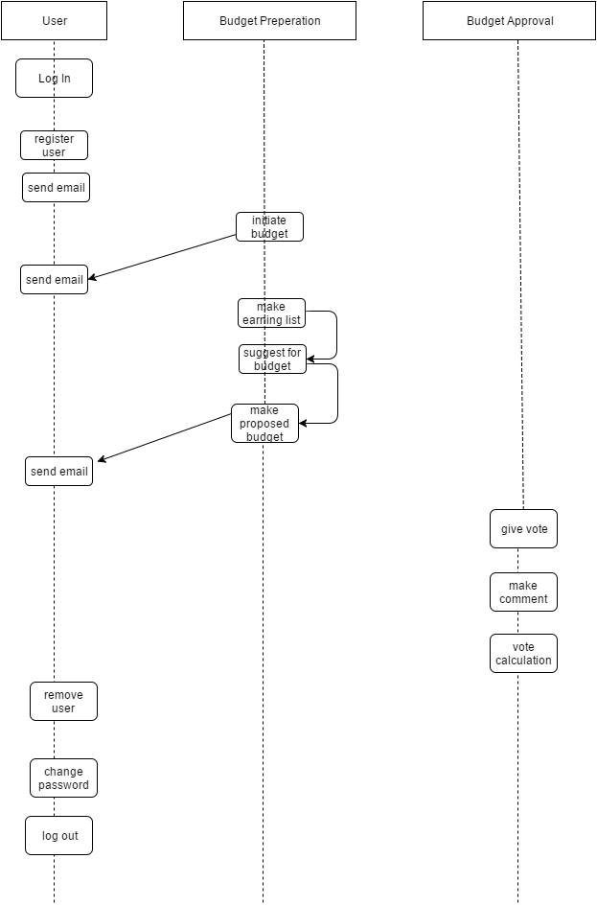

Figure 16: Sequence diagram of budget Planning System

# Chapter 10: Conclusion

We are pleased to submit the final SRS report on Budget Planning System. From this, the readers will get a clear and easy view of Budget Planning System. This system will help Budget Committee to plan and prepare a proper budget with more efficiency. This SRS document can be used effectively to maintain software development cycle. It will be very easy to conduct the whole project using this SRS. We have tried our best to remove all dependencies and make effective and fully designed SRS. We believe that reader will find it in order.